  

# A CRM APPLICATION TO MANAGE THE SERVICES OFFERED BY AN INSTITUTION

1. **PROJECT OVERVIEW INTRODUCTION**

EduConsultPro Institute recognizes the critical need for a sophisticated Customer Relationship Management (CRM) system to address the complexities of modern educational service delivery. As the institution experiences significant growth in student applications and diverse service requests, the proposed Salesforce CRM platform emerges as a transformative technological solution designed to revolutionize institutional interactions, streamline operational processes, and enhance overall service quality.

# OPERATIONAL FRAMEWORK AND CORE OBJECTIVES

The CRM application is meticulously engineered to create a centralized, intelligent ecosystem that facilitates seamless communication between the institution and its multifaceted stakeholders. By integrating advanced technological capabilities, the system aims to transcend traditional data management approaches, focusing instead on creating a comprehensive platform that optimizes service delivery, improves client satisfaction, and generates actionable insights for strategic decision-making.

# FUNCTIONAL DOMAINS AND SERVICE INTEGRATION ADMISSION PROCESS MANAGEMENT

The CRM will comprehensively transform the admission lifecycle through sophisticated technological interventions. By implementing automated document verification processes, real-time application tracking, and personalized communication workflows, the system ensures a transparent, efficient, and user- friendly application experience. Administrators will benefit from centralized applicant profile management and advanced analytics that provide deep insights into recruitment dynamics.

  

# 

# CONSULTING SERVICES ECOSYSTEM

A specialized module will be dedicated to managing consulting interactions with unprecedented precision. The platform will enable detailed service request logging, intelligent consultant assignment, comprehensive progress tracking, and historical interaction documentation. This approach ensures that each consulting engagement is meticulously monitored, allowing for continuous quality improvement and personalized service delivery.

# IMMIGRATION CASE MANAGEMENT

Recognizing the complexity of immigration-related services, the CRM will feature specialized modules designed to handle sensitive and intricate case requirements. The system will provide robust documentation tracking, compliance monitoring, critical deadline management, and secure communication channels. This approach ensures comprehensive support for complex immigration processes while maintaining the highest standards of data privacy and institutional reliability.

# TECHNOLOGICAL INFRASTRUCTURE AND USER EXPERIENCE MULTILAYERED INTERFACE DESIGN

The application will feature a sophisticated, role-based interface catering to diverse user requirements. The administrator dashboard will offer comprehensive analytics and management tools, while staff portals will provide robust operational management capabilities. Simultaneously, the client/student portal will deliver an intuitive, self-service platform that empowers users to interact seamlessly with institutional services.

# INTELLIGENT AUTOMATION AND ANALYTICS

Advanced technological features will distinguish the CRM platform, including automated appointment scheduling, intelligent reminder systems, predictive analytics, workflow automation, and real-time notification mechanisms. These capabilities will significantly reduce administrative overhead, minimize manual interventions, and create a more responsive, data-driven service environment.

  

# 

# STRATEGIC ADVANTAGES AND ANTICIPATED OUTCOMES OPERATIONAL EXCELLENCE

The CRM solution promises transformative benefits, including substantial reductions in administrative processing time, enhanced resource allocation, improved process standardization, and comprehensive performance tracking. By centralizing data and automating complex workflows, the institution can achieve unprecedented levels of operational efficiency.

# CLIENT EXPERIENCE TRANSFORMATION

Through transparent service tracking, personalized communication channels, faster response mechanisms, and comprehensive interaction histories, the CRM will revolutionize client engagement. The platform's user-centric design ensures that students and stakeholders receive timely, relevant, and high-quality service interactions.

# DATA-DRIVEN INSTITUTIONAL STRATEGY

The CRM's advanced analytics capabilities will generate profound insights, enabling institutional leadership to make informed strategic decisions. By providing comprehensive performance metrics, trend analysis, and continuous improvement mechanisms, the platform becomes more than a technological tool—it evolves into a strategic partner in institutional growth.

# IMPLEMENTATION AND FUTURE PERSPECTIVE

Leveraging the robust Salesforce CRM platform, EduConsultPro Institute is positioned to create a scalable, secure, and technologically advanced service management ecosystem. The solution represents a forward-thinking investment in institutional capability, promising to enhance operational transparency, optimize resource utilization, and ultimately deliver exceptional educational services.

This comprehensive CRM solution signifies EduConsultPro Institute's commitment to technological innovation, client satisfaction, and strategic excellence in educational service management.

  

# OBJECTIVES

**INSTITUTIONAL CONTEXT AND STRATEGIC VISION**

EduConsultPro Institute stands at a critical technological transformation point, recognizing the profound potential of advanced Customer Relationship Management (CRM) systems to revolutionize institutional service delivery. The Salesforce CRM implementation represents a holistic strategic approach to addressing complex organizational challenges, transcending traditional technological solutions by creating an integrated, intelligent ecosystem that fundamentally reimagines stakeholder interactions.

# TECHNOLOGICAL FOUNDATION AND STRATEGIC OBJECTIVES

**COMPREHENSIVE DATA INTEGRATION METHODOLOGY**

The CRM implementation focuses on creating a sophisticated data integration framework that enables seamless transformation of existing institutional information. By developing advanced spreadsheet-to-object conversion capabilities, the system will eliminate traditional data migration barriers, ensuri ng comprehensive, accurate, and instantaneous information transfer. This approach represents a quantum leap in institutional data management, converting fragmented data repositories into a unified, actionable intelligence platform.

# ARCHITECTURAL DESIGN PHILOSOPHY

The technological architecture is meticulously designed to balance flexibility, scalability, and operational efficiency. Unlike traditional monolithic systems, this CRM solution adopts a modular, adaptive approach that can dynamically respond to evolving institutional requirements. The framework prioritizes interoperability, ensuring that each technological component functions as an integrated element of a larger, cohesive ecosystem.

  

# 

# STRATEGIC BUSINESS GOAL DOMAINS

1. **CLIENT MANAGEMENT TRANSFORMATION**

The client management strategy transcends conventional database management, creating a sophisticated stakeholder relationship intelligence platform. By developing comprehensive client profiles that integrate historical interactions, preferences, and engagement patterns, the institute can develop nuanced, personalized engagement strategies. This approach transforms client data from passive records into active strategic assets.

# KEY FUNCTIONAL CAPABILITIES

* + 360-degree client profile development
  + Predictive interaction modeling
  + Personalized communication pathway generation
  + Comprehensive interaction history tracking

# ENHANCED ENGAGEMENT MECHANISMS

Communication technologies are strategically deployed to create intelligent, responsive engagement ecosystems. Automated communication workflows are designed with sophisticated contextual intelligence, enabling personalized, timely interactions that anticipate and address stakeholder needs proactively.

# COMMUNICATION STRATEGY COMPONENTS

* + Intelligent notification systems
  + Contextually adaptive communication templates
  + Multi-channel engagement platforms
  + Automated follow-up intelligence

# OPERATIONAL EFFICIENCY OPTIMIZATION

Automation emerges as a critical strategic lever for transforming institutional productivity. By systematically identifying and automating repetitive administrative processes, the CRM solution liberates institutional human capital, redirecting focus from transactional tasks to strategic value generation.

  

# 

# AUTOMATION FOCUS AREAS

* + Appointment scheduling algorithms
  + Document management workflows
  + Service update propagation
  + Compliance monitoring systems

# REVENUE AND RETENTION ENGINEERING

The CRM platform transforms into a sophisticated revenue intelligence mechanism, providing granular insights into conversion dynamics, marketing effectiveness, and client retention strategies. Advanced analytics enable predictive modeling of institutional performance trajectories.

# REVENUE OPTIMIZATION MODULES

* + Conversion pathway analysis
  + Lead generation intelligence
  + Marketing campaign performance tracking
  + Retention risk identification

# STRATEGIC DECISION INTELLIGENCE

Analytics capabilities are elevated from retrospective reporting to predictive strategic intelligence generation. Comprehensive dashboards provide leadership with real-time, nuanced insights enabling evidence-based strategic interventions.

# INTELLIGENCE GENERATION FEATURES

* + Dynamic performance visualization
  + Predictive trend analysis
  + Comparative institutional benchmarking
  + Strategic scenario modeling

  

# 

# SPECIFIC OUTCOME ARCHITECTURE INTEGRATED CLIENT INFORMATION ECOSYSTEM

A multilayered database architecture captures comprehensive client interactions, transforming raw data into strategic relationship intelligence. Each interaction becomes a datapoint in a complex relational mapping of institutional engagement.

# ADVANCED SERVICE TRACKING MECHANISMS

Consultation and service progression tracking systems are designed with unprecedented granularity, enabling real-time monitoring, predictive scheduling, and intelligent resource allocation.

# LEAD MANAGEMENT INTELLIGENCE PLATFORM

Sophisticated lead management tools transcend traditional sales pipeline tracking, providing nuanced insights into conversion dynamics, enabling continuous strategic refinement.

# SECURE DOCUMENT MANAGEMENT FRAMEWORK

A robust, compliance-driven document management system ensures data integrity, accessibility, and regulatory adherence through advanced security protocols.

# MEASURABLE STRATEGIC OUTCOMES

* + 15% lead-to-conversion ratio enhancement
  + 30% client follow-up response time reduction
  + 90% client satisfaction achievement
  + 100% institutional interaction tracking

This transformative CRM implementation represents a holistic reimagining of institutional service management, integrating technological innovation with strategic intelligence to create a future-ready organizational ecosystem.

  

# 

# SCREENSHOTS

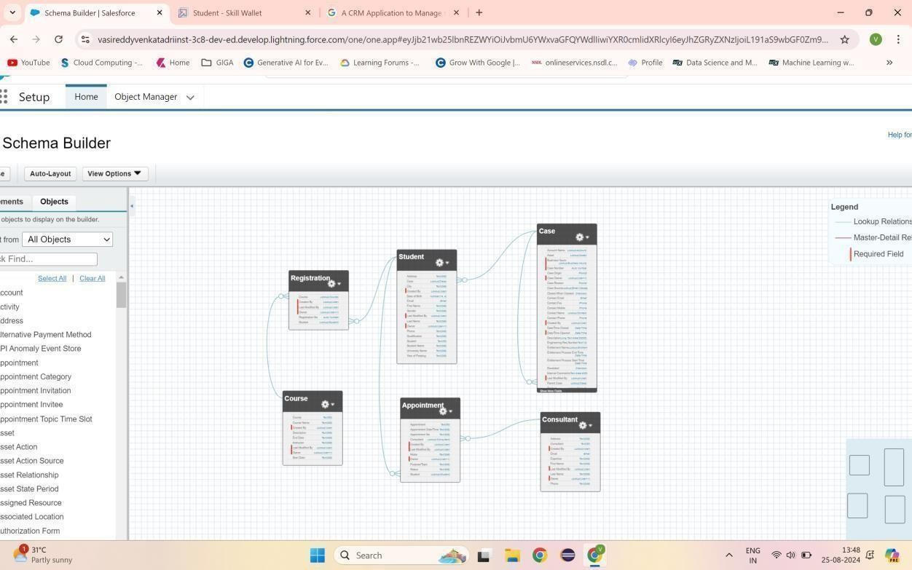

**Fig1.1 Lookup relationship among Objects**

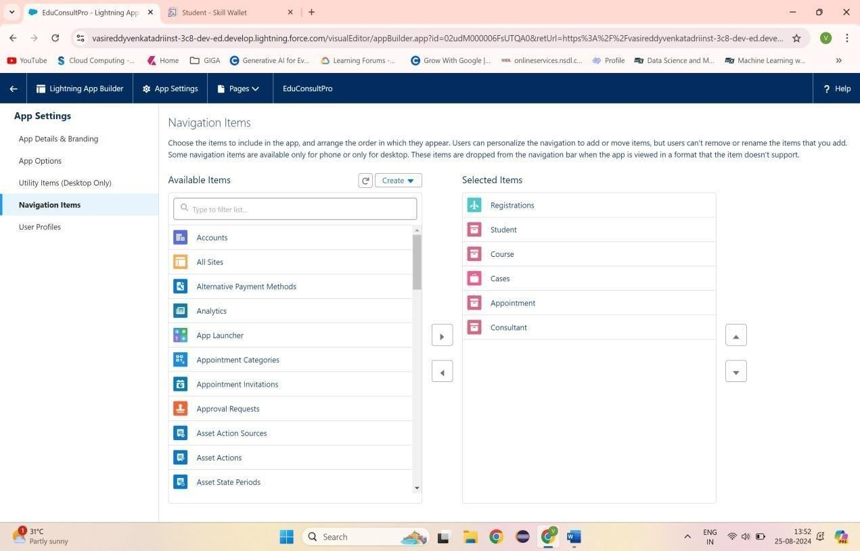

# Fig1.2 Adding items to EduConsultPro

  

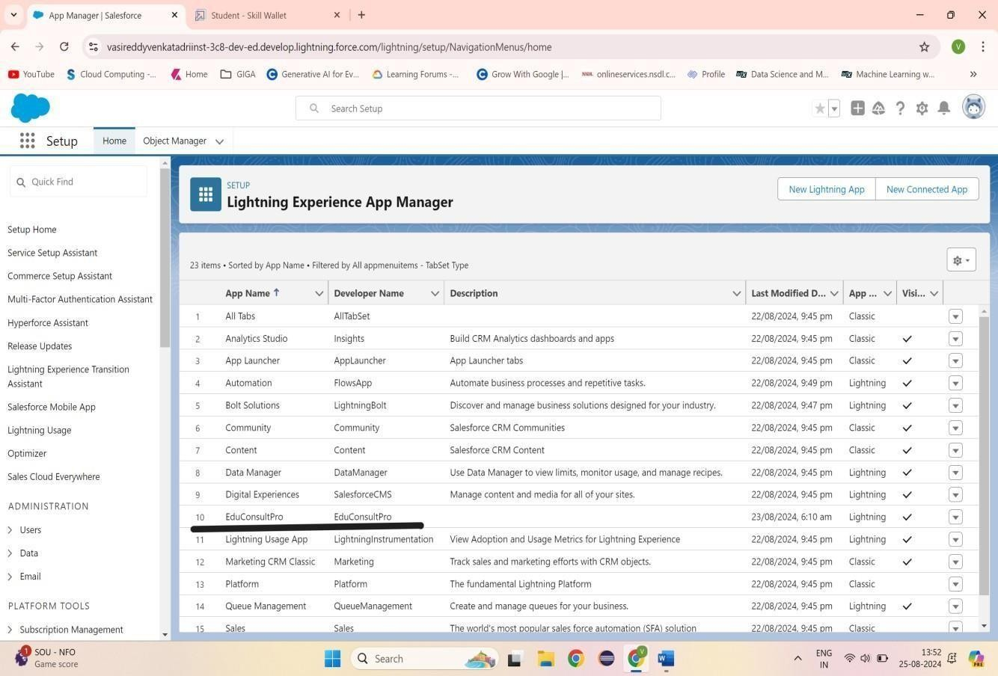

# Fig1.3 EduConsultPro Lightning App

1. **SALESFORCE KEY FEATURES AND CONCEPTS UTILIZED**

# TECHNOLOGICAL TRANSFORMATION OF STUDENT REGISTRATION

The EduConsultPro Student Flow represents a sophisticated technological solution designed to revolutionize the institutional registration process by creating an intelligent, user-friendly application ecosystem. This innovative approach leverages Salesforce's advanced technological capabilities to transform traditional registration methodologies into a seamless, integrated experience that prioritizes user engagement and operational efficiency.

  

# 

# STUDENT INFORMATION CAPTURE MECHANISM

The registration journey begins with a meticulously designed "Student Info" screen element, serving as the primary interface for comprehensive student data collection. By implementing a specialized record variable, the system creates a lightweight, intuitive data capture mechanism that enables efficient retrieval and processing of student information directly from the Salesforce student object. This approach ensures a smooth, user-friendly experience that minimizes administrative friction while capturing critical student details with precision and care.

# RECORD CREATION AND DATABASE INTEGRATION

Upon completing the initial information capture, the system immediately transitions to the "Create Student Record" element, a critical component responsible for saving student input directly into the Salesforce database. This instantaneous record creation ensures real-time data integration, providing immediate validation and system acknowledgment of the student's registration attempt. The process transforms raw input into a structured, meaningful institutional record, laying the foundation for subsequent registration steps.

# COURSE SELECTION AND ROUTING WORKFLOW

The course selection stage represents a pivotal moment in the registration process, implemented through a sophisticated "Course Screen" element. A carefully designed picklist named "Select Course" presents students with comprehensive options including IELTS, GRE, GMAT, Duolingo, and TOEFL. This approach provides students with clear, structured choices while enabling the system to implement intelligent routing mechanisms.

The accompanying "Selecting Course" decision element serves as an advanced routing mechanism, dynamically managing the registration flow based on the student's course selection. By implementing conditional logic, the system can retrieve specific course records from the Course object, ensuring precise, context- aware registration processing. This intelligent routing transforms course selection from a simple choice into a comprehensive, personalized registration pathway.

  

# 

# REGISTRATION RECORD GENERATION

Following course selection, the system leverages a Create Records element to generate a comprehensive registration record within the Registration object. This critical step associates the selected course with the previously captured student information, creating a holistic registration documentation process. The approach ensures that each registration becomes a rich, multidimensional data point capturing the complete context of the student's institutional engagement.

# COMMUNICATION AND CONFIRMATION STRATEGY

The registration workflow incorporates a sophisticated communication mechanism designed to provide immediate, personalized confirmation. By developing specialized text template resources for email body and subject, the system ensures that students receive comprehensive, timely information about their registration. The "Send Email to Student" action element enables dynamic population of student-specific details, creating a personalized communication experience.

# FINAL CONFIRMATION AND USER EXPERIENCE

The registration process culminates in a carefully designed "Success Screen" that provides clear, reassuring confirmation of the completed registration. By displaying a message confirming successful registration and advising students to check their emails, the system creates a positive, supportive conclusion to the enrollment journey.

# STRATEGIC SIGNIFICANCE

The EduConsultPro Student Flow transcends traditional registration systems, emerging as a strategic technological solution that redefines institutional enrollment processes. By combining advanced Salesforce capabilities with a user - centric design philosophy, the implementation creates an intelligent, adaptive ecosystem that enhances both operational efficiency and stakeholder experience.

  

This comprehensive approach represents a quantum leap in institutional registration technology, transforming what was once a complex, administrative process into a seamless, intelligent, and user-friendly experience.

# SCREENSHOT

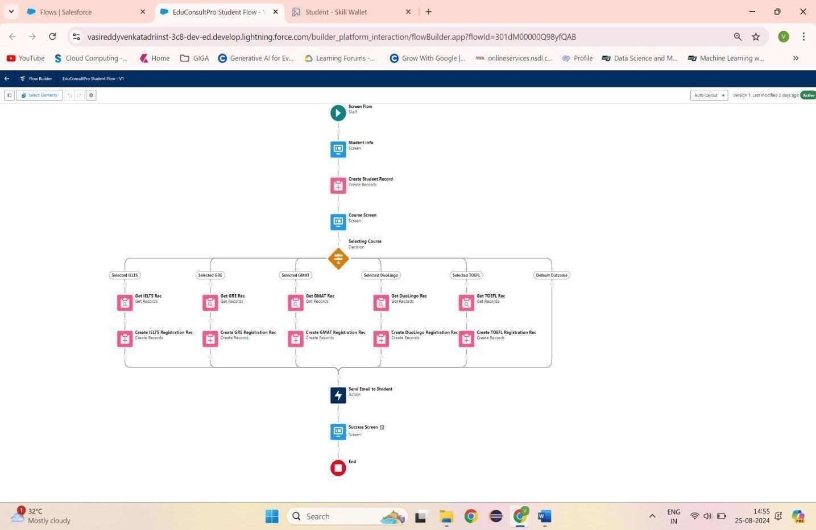

**Fig1.4 EduConsultPro Student Flow**

# DETAILED STEPS TO SOLUTION DESIGN CREATE USERS

Created new user in Salesforce by navigating to Setup→Administrative→ Users→New User. Entered "Consultant" for the second name and entered "Salesforce Platform" as the license type. I applied the profile "Standard Platform User," checked all required fields for data, and saved the record of the new user.

  

Configured user settings: Browse to Setup → Administration → Users → Edit the user profile Scrolled down to the Approver Settings section, selected "Consultant" in the Manager Field, At the bottom of the screen, click Save**.**

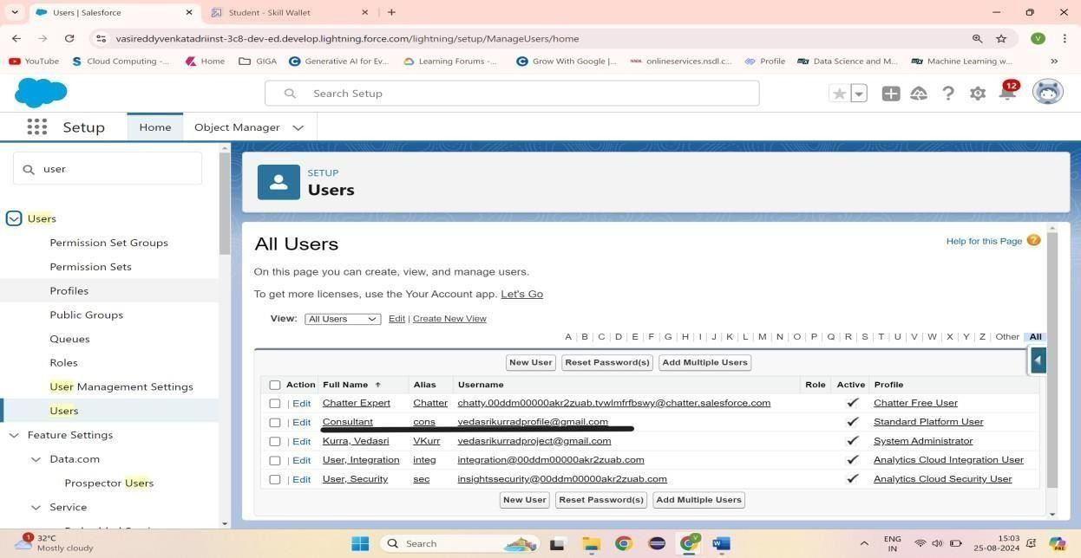

# Fig1.5 User

**CREATE AN APPROVAL PROCESS FOR PROPERTY OBJECT**

Created email template in Salesforce. From Setup, I input "Templates" in the Quick Find box and clicked on "Lightning Email Templates", and clicked the toggle to on. Opened the App Launcher, searched for "Email Templates" from the search box, and saved. Created a new folder with the desired name. Created an new email Template and selected the new created folder. The specified text got pasted into the HTML Value to create this, in my case, "Submission Template” Designed two more email templates for approving and rejecting requests, ditto the first one.

Earlier, I did set up the approval process. I went to Setup and typed "Approval" in the Quick Find box, and clicked on "Approval Processes." I selected to manage approval processes for "Appointment" and clicked "Create New Approval Process" using the Jump Start Wizard. I named the process "Appointment Approval" and under the approver settings, I used the setting "Option Automatically assign an approver using a standard or custom hierarchy field" of

  

"Manager." I set the "Next Automated Approver Determined By" field to "Manager."

Made the following changes to the Record Editability Properties: Prepended "Administrator OR the currently assigned approver" to the list Saved the process and checked out the form Made a new Field Update under the Initial Submission Actions with Name "Submitted" and configured it to make the update to the field "Appointment: Status" with "Pending".

Also created a new Email Alert type "Submission Email Alert," auto -populate the Unique Name, selected the "Submission Template" Email Template, selected the recipient type to the user's Name. Repeated that for the Final Approval and Final Rejection actions and set those two up the same way.

# SCREENSHOTS

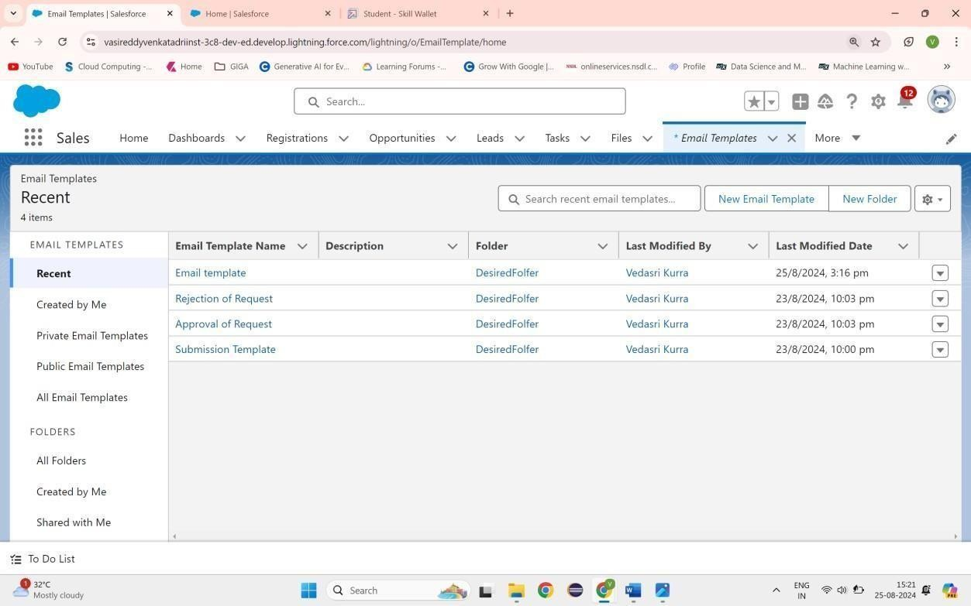

**Fig1.6 Email Template**

  

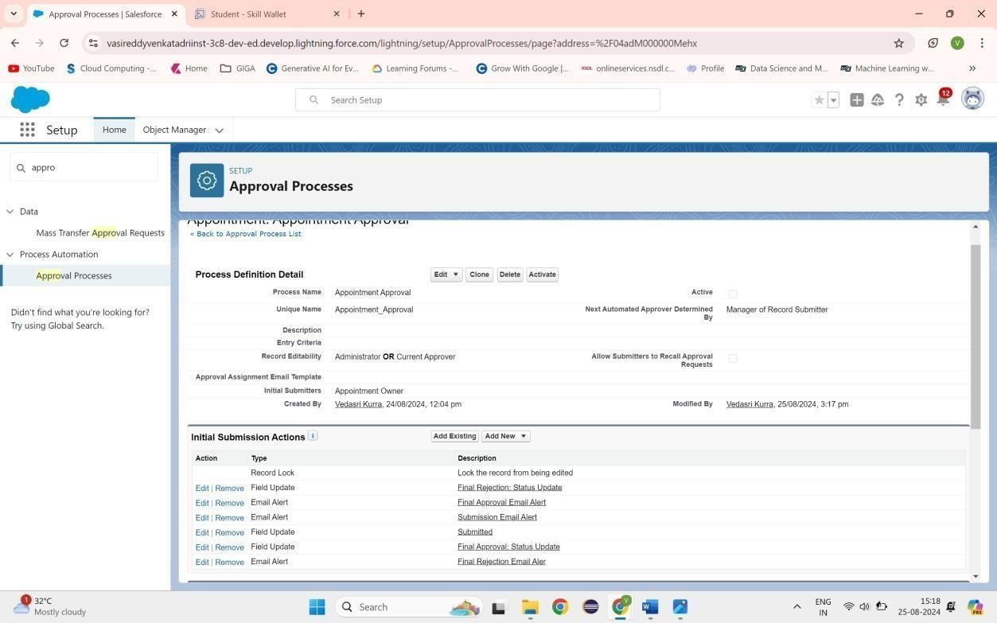

# Fig1.7 Approval Process

**CREATE A RECORD TRIGGERED FLOW**

A **CRM application** designed to manage the services offered by an institution, such as an educational consultancy, aims to streamline operations, track service delivery, and enhance customer experiences.

To create a **Record-Triggered Flow** for such an application, start by selecting the triggering object (e.g., "Student Inquiry" or "Service Request") and defining the entry criteria. This could include conditions such as when the inquiry status is updated to "New" or when a service request is marked "Complete.

" Use actions like "Create Record" to log follow-ups, "Update Record" to modify fields, or "Send Email" to notify relevant stakeholders. Leverage decision elements to guide the flow based on conditions, ensuring a tailored response for each scenario. This approach not only optimizes workflow management but also helps the institution maintain consistent, high-quality service standards.

  

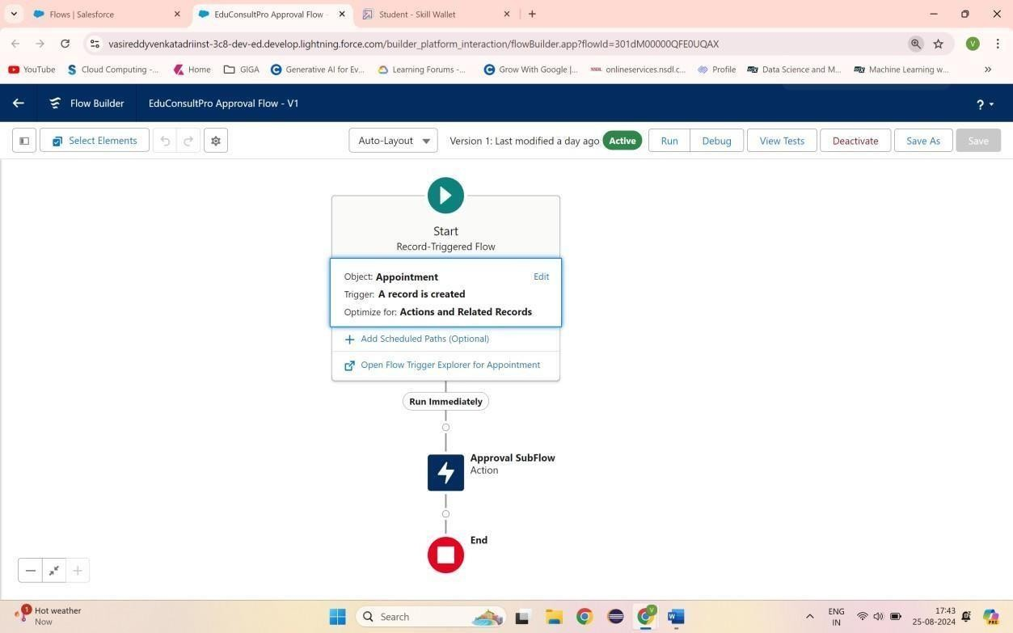

# Fig1.8 EduConsultPro Approval Flow

**CREATE A SCREEN FLOW FOR EXISTING STUDENT TO BOOK AN APPOINTMENT**

Configured an end-to-end flow in Salesforce for student appointments and cases management. Added a Screen element called "Get Student Info" to collect the student's name and email, and added a GET Record element to retrieve student details depending on the name and email collected.

Added a Decision element to route between "Appointment" and "Case" depending upon the student's wishes. Added a Screen element labeled "Appointment Booking Screen" to gather details for appointments in case an appointment has been booked.

Inserted a GET Record element to obtain consultant details based on the selected name of the consultant. Applied a Create Records element to create a new appointment record with appropriate details.

Added a Screen element and named it "Confirmation Screen" to let the student see details of the appointment confirmation.

  

Added a Subflow element for case management and named it "Create Student Case" for creation of a case. Finally, save the flow as "EduConsultantPro Existing Student Flow" and prepare for deployment.

# SCREENSHOT

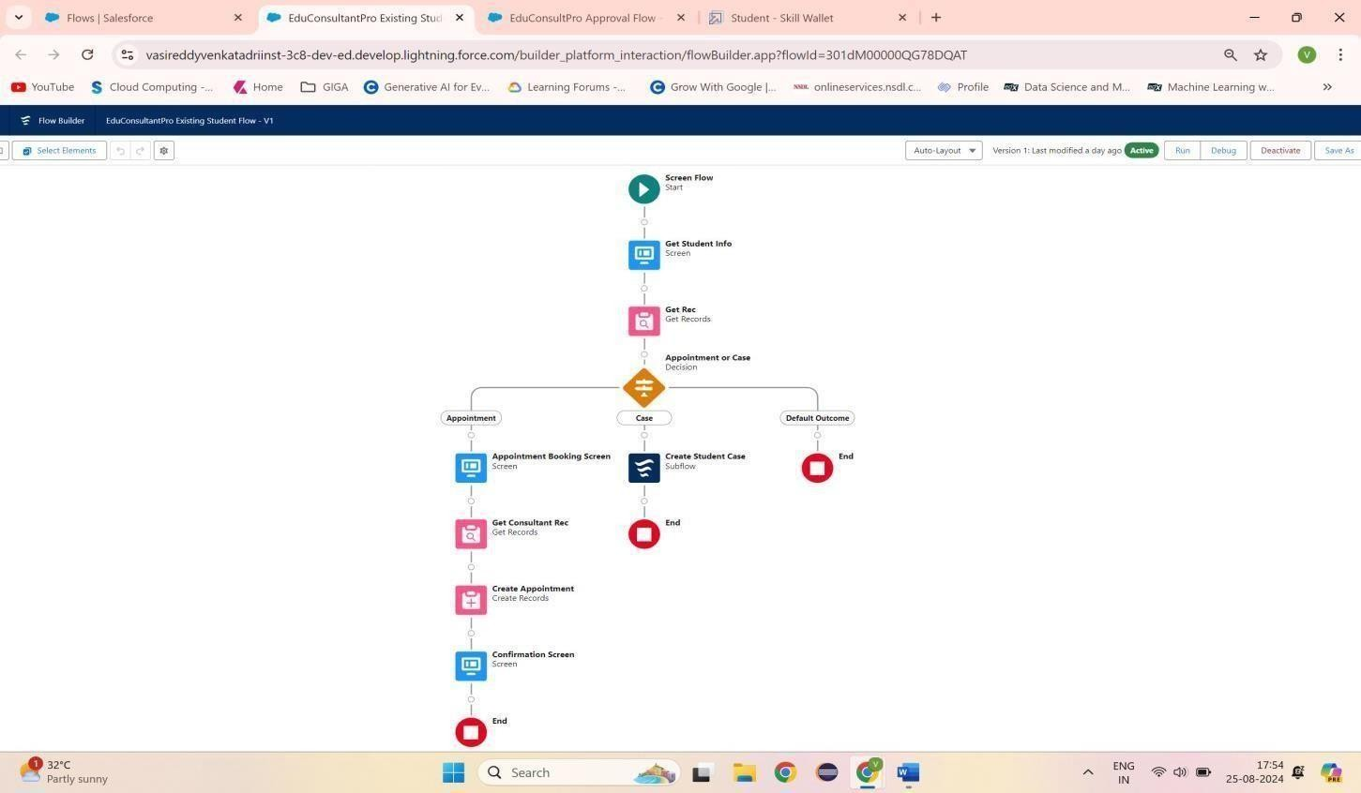

**Fig1.9 EduConsultantPro Existing Student Flow**

# CREATE A SCREEN FLOW TO COMBINE ALL THE FLOWS AT ONE PLACE

A new Screen Element in the flow was added labelled as "Welcome Screen". Inside this screen, a Display Text component was added and was labelled as "Success Message." Entered the given text into the Resource Picker box so that the welcome message by EduConsultantPro describes the services and support it provided. Added another Screen Element following the Welcome Screen, labeled "Existing or New Student Confirmation Screen."

  

Added a Radio Button component with the label "Are you an Existing Student?" Created two choices: "Yes" and "No."Then added an Action Element of type Decision and named it "Decision 1," placing it next to the Existing or New Student Confirmation Screen.Set up the decision criteria with the outcome labeled "If Existing Student." The condition will be when the resource {! Are_you_a_Existing_Student} is equal to the value {! Yes}.Added the second outcome for "No.". Inserted a Subflow Element in the "If Existing Student" path and selected "EduConsultantPro Existing Student Flow" and labelled it as "Existing Student Flow."

Saved the flow under the name "EduConsultantPro Existing Student Flow." Inserted another Subflow Element in the "If Not an Existing Student" path, selecting the "EduConsultantPro Student Flow" and labelling it "New Student Flow." Saved this flow with the name "EduConsultPro Flow.

" Finalized by saving the entire flow, naming it "EduConsultPro Flow.”

# SCREENSHOT

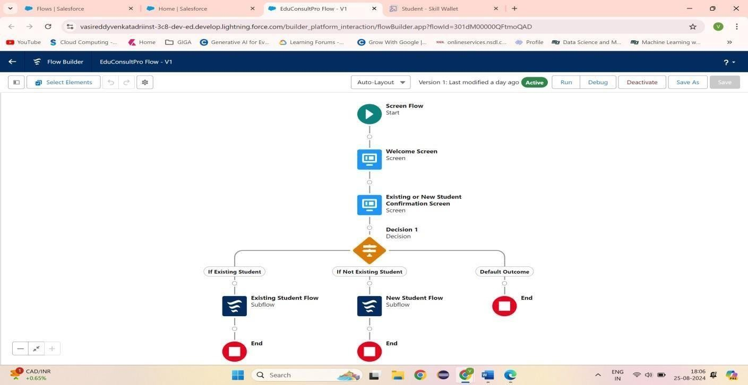

**Fig1.10 EduConsultPro Flow**

  

# 

# TESTING AND VALIDATION TESTING

Testing the CRM application, *EduConsultant Pro*, ensures its reliability, functionality, and performance align with institutional needs. During the **unit testing phase**, individual modules, such as user registration, service catalog management, and appointment scheduling, are tested to ensure proper functionality. This is followed by **integration testing**, which verifies that different modules, such as linking client data to service bookings, work together seamlessly. Furthermore, **system testing** is conducted to validate the application’s overall behaviour under various scenarios, such as handling concurrent user access or retrieving large datasets. Usability testing is also performed to confirm the application is user-friendly and intuitive for consultants and clients.

**Performance and security testing** are critical to ensure the CRM can handle high traffic and protect sensitive client data. Load testing is conducted to analyse how the application performs under stress, while penetration testing identifies potential vulnerabilities that could lead to unauthorized data access. Compatibility testing ensures the CRM works across multiple devices and browsers, delivering a consistent user experience. Issues discovered during testing are documented and fixed to meet the institution’s quality standards.

# VALIDATION

Validation of the *EduConsultant Pro* CRM application ensures it fulfils the business requirements and meets user expectations. This is achieved by conducting **requirement validation**, where the developed features are cross- checked with the original functional specifications. For instance, features like service tracking, report generation, and email notifications are verified to ensure they align with the institution's goals. Validation sessions with stakeholders, including consultants and administrative staff, help ensure the CRM addresses real-world operational needs.

User acceptance testing (UAT) forms a significant part of validation, where end- users interact with the application in a controlled environment. Their feedback is used to determine whether the application is ready for deployment. Validation also includes assessing compliance with legal and regulatory requirements, such

  

as data protection laws. By thoroughly validating the application, institutions can be confident that *EduConsultant Pro* is not only functional but also tailored to enhance operational efficiency and client satisfaction.

# CREATE A LIGHTNING APP PAGE

The "EduConsultant Pro" CRM application is a cutting-edge solution designed to streamline service management for educational institutions. This application is tailored to meet the needs of administrators, consultants, and students, offering a centralized platform to track and manage interactions, schedules, and services efficiently.With its user-friendly interface and robust functionality, the application ensures that the institution delivers top-notch consulting services while maintaining excellent customer relationships. The Lightning App Page within "EduConsultant Pro" serves as the core interface for managing institutional services. It is built using Salesforce Lightning components, which provide a responsive and dynamic user experience.This page integrates various features, including dashboards to track key performance indicators, service management tools to schedule and monitor consultations, and a comprehensive view of client details. Administrators can quickly access records, manage workflows, and track service delivery using this highly customizable page.

# BENEFITS AND USER EXPERIENCE

The Lightning App Page enhances productivity and ensures seamless communication between consultants and students.

Its visually appealing layout allows users to drag-and-drop components, customize their view, and focus on their priorities.

With real-time updates, automated notifications, and mobile accessibility, the page empowers users to stay connected and informed.

Ultimately, "EduConsultant Pro" elevates service quality and fosters stronger relationships, helping institutions thrive in a competitive educational environment.

  

# SCREENSHOTS

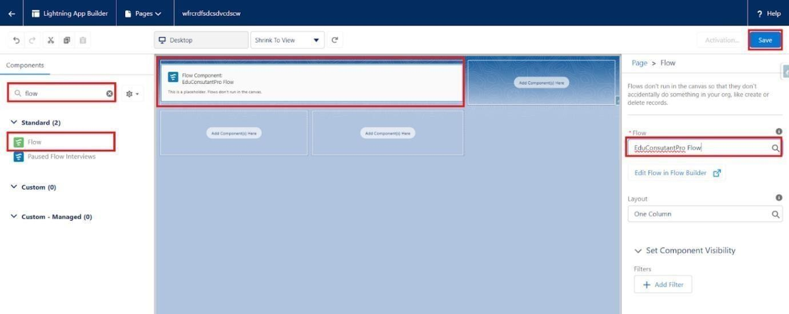

**Fig1.11 lightning app page**

# KEY SCENARIOS ADDRESSED BY SALESFORCE IN THE IMPLEMENTATION PROJECT

**Optimizing Client Lifecycle Management** Salesforce aids in managing the entire lifecycle of an EduConsultant Pro client, from the initial inquiry stage to the delivery of services. The platform enables centralized tracking of leads, appointments, and consultations, allowing the institution to offer tailored educational consulting services efficiently. Automated appointment scheduling using Salesforce Flow and integration with Einstein AI enables predictive analytics, helping consultants understand client needs proactively. Additionally, the platform’s analytics dashboards provide actionable insights into the institution’s performance, ensuring transparency and continuous improvement in service offerings.

  

**Enhancing Collaboration and Scalability** With Salesforce, EduConsultant Pro can improve collaboration between departments like marketing, sales, and service teams. The use of Salesforce Chatter fosters real-time communication and information sharing, ensuring all team members are aligned in delivering exceptional services. Moreover, the scalability of Salesforce’s cloud-based infrastructure ensures that the institution can handle growing client bases without compromising performance. By leveraging Salesforce’s AppExchange for industry-specific tools and customizing the CRM as needed, EduConsultant Pro can future-proof its operations while remaining adaptive to evolving client demands.

# CONCLUSION

The contemporary Customer Relationship Management (CRM) application represents a transformative technological solution designed to revolutionize institutional service management through an integrated, holistic approach. By creating a centralized platform that transcends traditional operational boundaries, the application emerges as a sophisticated ecosystem that fundamentally reimagines how institutions interact with their stakeholders, harmonizing technological capabilities with strategic organizational objectives.

The architectural design prioritizes a comprehensive stakeholder experience, creating an interconnected environment that seamlessly bridges communication channels between clients, staff, and administrators. This approach eliminates organizational silos, generating a transparent, responsive platform that enhances institutional effectiveness and service delivery by transforming fragmented processes into a cohesive, intelligent management system.

The system's core functionality is built upon sophisticated, dynamically interconnected modules that work in perfect synchronization. Customer information management serves as the foundational pillar, transforming raw data into strategic relationship intelligence. By developing intricate client profiles that capture detailed interaction histories, preferences, and engagement patterns, the application converts every client interaction into a multidimensional datapoint enabling deeply personalized, context-aware service delivery. Workflow automation emerges as a critical strategic lever for institutional transformation.

  

By systematically identifying and streamlining repetitive administrative processes, the CRM solution liberates institutional human capital, redirecting focus from transactional tasks to high-value strategic initiatives. Intelligent automation protocols ensure consistent, efficient service deliverywhile maintaining the highest standards of accuracy and personalization, creatingan adaptive ecosystem that can evolve with changing institutional requirements.

Security and scalability are intricately woven into the application's architectural design, ensuring comprehensive data protection, regulatory compliance, and future-ready technological infrastructure. Robust security protocols protect sensitive information while providing flexible, role-based access mechanisms that enable sophisticated user management and data governance.The application's advanced analytics capabilities transform data into strategic insights, providing leadership with comprehensive visualization of institutional performance, stakeholder engagement, and potential optimization opportunities.

By generating predictive models and comprehensive performance dashboards, the CRM becomes more than a technological tool—it evolves into a strategic partner driving continuous institutional improvement.Technology integration represents a critical design philosophy, ensuring the CRM can seamlessly connect with existing institutional systems, third-party applications, and emerging technological platforms. This approach creates an open, adaptable ecosystem that can incorporate new technologies, respond to changing stakeholder needs, and maintain technological relevance in a rapidly evolving digital landscape.

Ultimately, the CRM application transcends traditional service management paradigms, representing a holistic approach to institutional engagement. By combining sophisticated technological capabilities with a deep understanding of stakeholder dynamics, the system creates a transformative platform that enables institutions to deliver exceptional services, build meaningful relationships, and continuously evolve their operational strategies

  

# 

# REFERENCES

1. **SalesForce**

[https://karpagavinayagacollegeof-b7-dev-](https://karpagavinayagacollegeof-b7-dev-ed.develop.lightning.force.com/lightning/setup/SetupOneHome/home) [ed.develop.lightning.force.com/lightning/setup/SetupOneHome/home](https://karpagavinayagacollegeof-b7-dev-ed.develop.lightning.force.com/lightning/setup/SetupOneHome/home)

# Trailhead

[https://trailhead.salesforce.com/users/smartbridgesupport/trailmixes/trailmix- by-](https://trailhead.salesforce.com/users/smartbridgesupport/trailmixes/trailmix-by-smartinternz-developer) [smartinternz-developer](https://trailhead.salesforce.com/users/smartbridgesupport/trailmixes/trailmix-by-smartinternz-developer)

# GuidedProject

<https://nme.smartinternz.com/Student/guided_project_info/15026>

# SmartInternz

<https://nme.smartinternz.com/Student/guided_project_workspace/15026>

# CRM Lightning App

https://karpagavinayagacollegeof-b7-dev- ed.develop.lightning.force.com/lightning/page/home

# Microsoft Dynamics 365:

A comprehensive CRM and ERP platform for managing services, including custom modules for institutions. Reference: [Microsoft Dynamics 365](https://dynamics.microsoft.com/)

# HubSpot CRM:

A widely used CRM for managing customer interactions, services, and workflows. Ideal for small-to-medium-sized institutions. Reference: [HubSpot CRM](https://www.hubspot.com/)